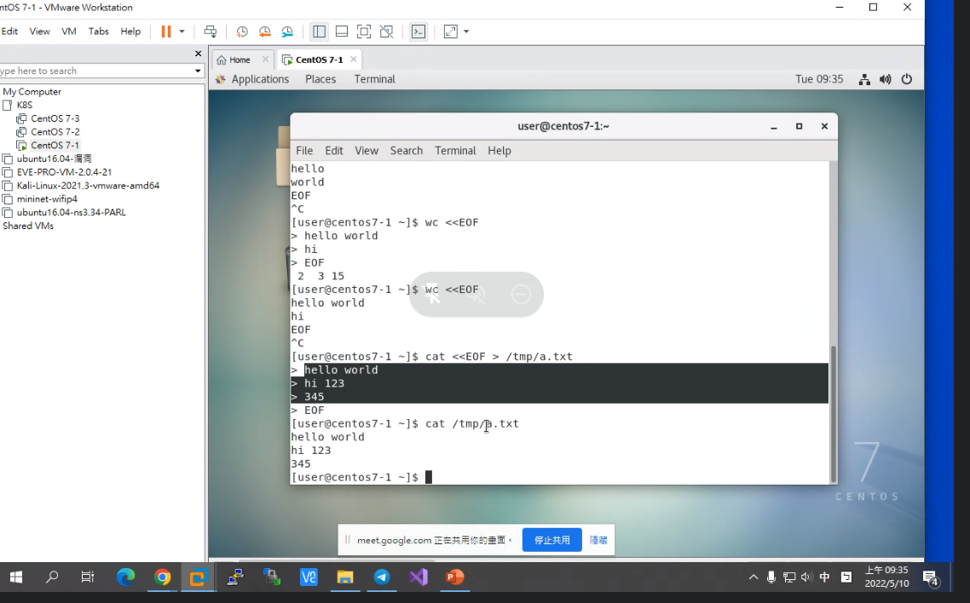

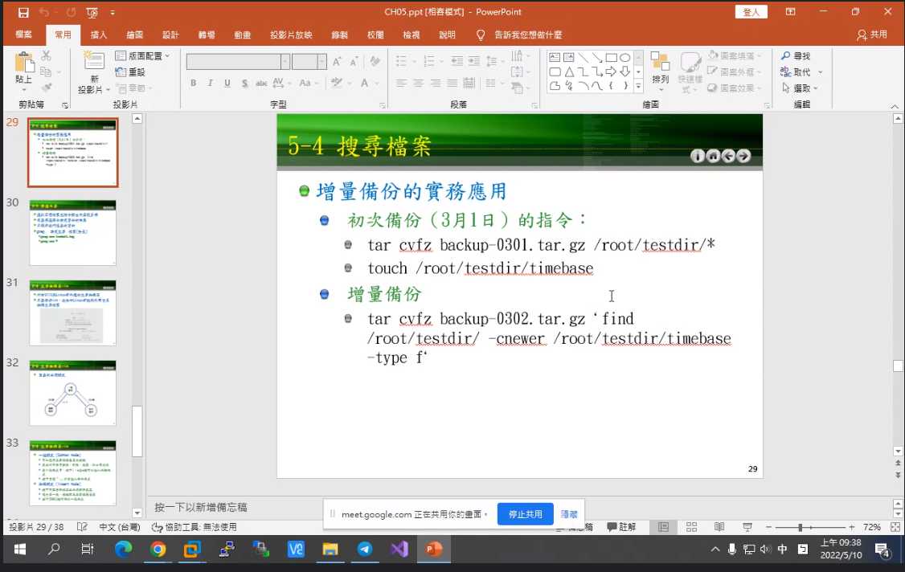

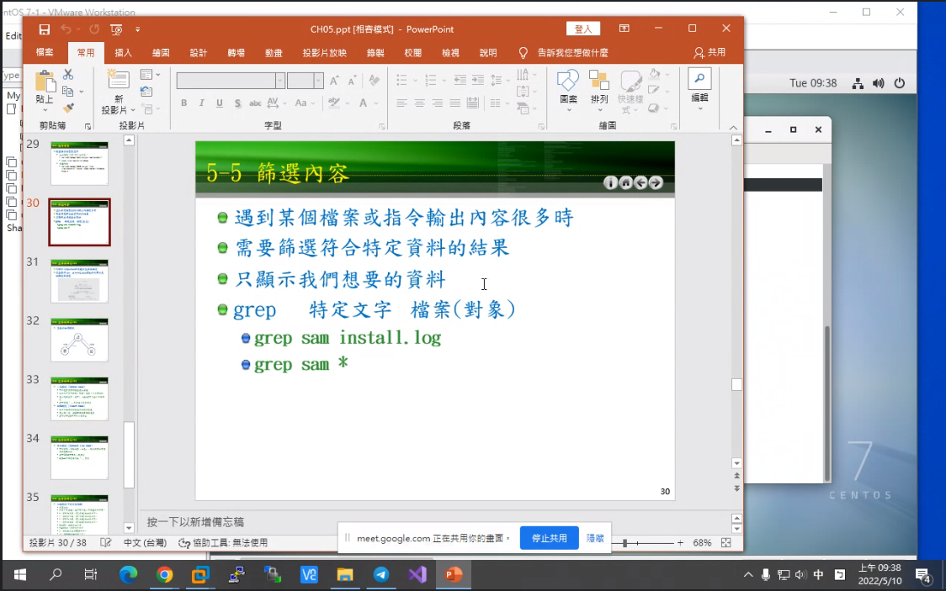

Wildcard: It is a regular expression used to match the file name to express the content of the file (regular expression)

Wildcard rules:

\* represents any character (0 or more)

? represents a character

[ ] The middle is a combination of characters, only any one of them is matched

cat httpd.conf | grep -v "^$" | grep -v "^#"